**Problem Statement: Enhancing Microsoft’s Operational and Market Performance**

Microsoft, a global technology leader, operates in diverse product categories, including Windows, Xbox, Surface, Dynamics 365, and Azure. The dataset reveals key performance metrics such as revenue, profit, market share, and customer satisfaction across multiple regions and product categories. While Microsoft demonstrates strong revenue generation and market presence, there are critical areas for improvement and opportunities for optimization.

1. **Revenue and Profitability Gaps**: The dataset highlights uneven profit margins across product categories, with some products (e.g., Surface and Xbox) showing lower profitability despite high revenue. This suggests potential inefficiencies in cost management, such as elevated COGS and underperforming operational margins in specific regions.
2. **Customer Experience and Retention**: While customer satisfaction scores are generally high for subscription-based services, hardware products like Xbox and Surface show variability in Net Promoter Scores (NPS) and Subscription Renewal Rates. This inconsistency may impact customer loyalty and long-term retention.
3. **Operational Efficiency**: The dataset reveals disparities in employee productivity and resource allocation across regions. For instance, regions with higher R&D spend and employee counts do not always correlate with proportional increases in revenue or active user growth, indicating potential inefficiencies in workforce deployment and investment prioritization.
4. **Market Share and Competitive Positioning**: Market share data shows significant variation across regions, with products like Dynamics 365 and Surface struggling to capture substantial shares in emerging markets like MEA and LATAM. This suggests a need for targeted market strategies and localized offerings to enhance competitiveness.
5. **Service Quality and Reliability**: Service downtime and bug reports, particularly for software and subscription services, remain critical pain points. High bug occurrences in certain products, coupled with extended downtime, risk tarnishing Microsoft’s reputation for reliability and could negatively impact customer satisfaction and revenue.
6. **Underutilization of Marketing and R&D Spend**: Despite significant marketing and R&D investments, some products and regions exhibit underwhelming returns. This calls for better alignment of spending with strategic objectives to maximize ROI.

**Opportunity:**

By leveraging data analytics and business intelligence, Microsoft can address these challenges and optimize its operations. Key areas of focus should include:

* Improving cost management and profit margins across underperforming products.
* Enhancing customer retention strategies by addressing NPS and renewal rate inconsistencies.
* Streamlining operational efficiency through better resource allocation and workforce utilization.
* Tailoring regional strategies to boost market share in emerging markets.
* Reducing service downtime and bug occurrences to maintain customer trust and satisfaction.

By implementing data-driven strategies, Microsoft can strengthen its competitive positioning, enhance customer experience, and maximize operational efficiency, ensuring sustained growth and market leadership.

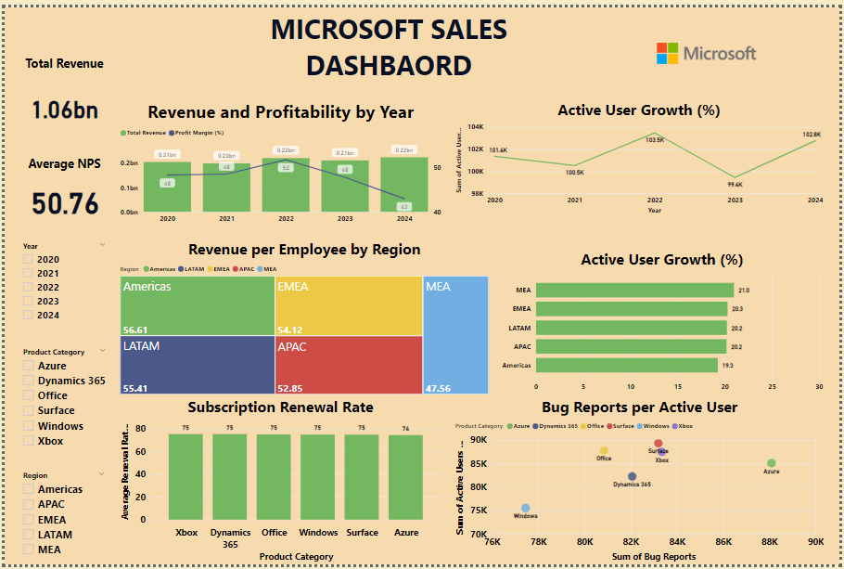

**1. Total Revenue**

* **What It Shows**:  
  The total revenue generated across all years, products, and regions, giving a snapshot of Microsoft’s financial performance. At **$1.06 billion**, it demonstrates the company's ability to drive sales and highlights the overall scale of its operations. This figure sets the foundation for deeper analysis, such as identifying which regions, product categories, or time periods contributed most to this revenue. It also helps gauge how well Microsoft is leveraging its diverse portfolio to meet market demands.

**2. Profit Margin (%)**

* **What It Shows**:  
  This KPI tracks profitability trends over time, showing how much profit Microsoft retains after covering costs (e.g., production, operations). The chart indicates that while total revenue has increased, profit margins have decreased from **48.3% in 2020** to **42.9% in 2024**, which could signal inefficiencies in cost management or increased investments (e.g., in R&D or marketing). A declining trend may suggest rising operational challenges, requiring a deeper dive into cost structures to identify inefficiencies.

**3. Average Net Promoter Score (NPS)**

* **What It Shows**:  
  The **Average NPS** of **50.76** reflects customer satisfaction and loyalty across Microsoft’s product lines. A mid-level NPS indicates customers are satisfied but not overwhelmingly enthusiastic about the company’s offerings. This suggests opportunities for improvement in customer experience, especially for products with lower satisfaction scores. A breakdown of NPS by region or product category could reveal which segments require focused efforts to build stronger customer loyalty.

**4. Subscription Renewal Rate**

* **What It Shows**:  
  This KPI measures customer retention by tracking the percentage of users renewing subscriptions. Products like **Azure** and **Office** exhibit higher renewal rates, reflecting strong customer satisfaction and continued usage. Lower rates for **Dynamics 365** and **Xbox** indicate possible issues with product value, customer engagement, or market competition. These trends provide insights into customer behavior and help prioritize retention strategies to improve long-term revenue stability.

**5. Active User Growth (%)**

* **What It Shows**:  
  This chart visualizes year-over-year changes in the number of active users across Microsoft’s products. While growth peaked in **2022**, it dipped sharply in **2023** before recovering in **2024**, suggesting fluctuations in user engagement due to factors such as market trends, product updates, or competition. Tracking these changes helps identify periods of success or underperformance and provides actionable insights to enhance customer engagement strategies.

**6. Revenue per Employee**

* **What It Shows**:  
  This KPI examines workforce productivity by calculating how much revenue is generated per employee. Regions like **Americas** lead at **$56.61 per employee**, indicating high productivity and efficient resource utilization. In contrast, **MEA** trails at **$47.56 per employee**, suggesting potential inefficiencies in workforce allocation or operational execution. This KPI helps identify regions where better resource management or employee training could improve performance.

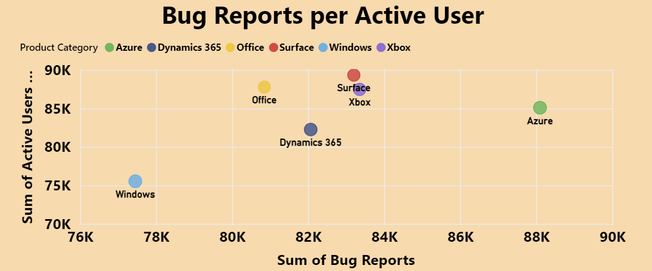

**7. Bug Reports per Active User**

* **What It Shows**:  
  This scatter plot analyzes product reliability by comparing the number of bug reports against active user counts, with bubble size representing the number of bug reports per million users. For instance, **Azure** and **Windows** have a high volume of bug reports relative to their large user bases, highlighting potential quality concerns. Conversely, **Office** and **Dynamics 365** exhibit fewer bugs, indicating better reliability. This visualization helps pinpoint products requiring immediate attention to enhance reliability and customer satisfaction.

**Revenue and Profitability by Year:**

**What It Shows:**

This bar and line chart visualizes **Total Revenue** and **Profit Margin (%)** over the years 2020 to 2024, providing insights into revenue growth and profitability trends.

* **Revenue Performance**: The green bars represent annual revenue, which shows steady growth from **$0.21 billion in 2020** to **$0.22 billion in 2024**, indicating stable sales performance across the years. The increase highlights Microsoft’s consistent ability to generate revenue across its product lines and regions.
* **Profit Margin Trends**: The blue line tracks profit margin percentages, starting at **48% in 2020**, peaking at **52% in 2022**, and then declining to **43% in 2024**. This declining trend suggests potential challenges in cost management, operational efficiency, or increased investments in areas such as R&D or marketing.
* **Combined Insight**: While revenue remains stable or slightly increases, the decreasing profit margin emphasizes rising costs or inefficiencies that are impacting overall profitability. This highlights the need for strategic measures to optimize costs and improve margins.